Midterm Project Report
Prediction of Progression-Free Survival in Breast Cancer Patients
Muxin Li, Xinyi Yao, Yumeng Lu
Progression-free survival (PFS) is an important endpoint in breast cancer research because it summarizes the time from diagnosis to disease progression or death. In this project, first, using the 1990–1995 cohort, we developed a prediction model for log-transformed progression-free survival (PFS) to understand how demographic, tumor, and treatment characteristics relate to breast cancer prognosis. Second, we evaluated whether that original model generalizes to a later cohort diagnosed in 2000–2005 and, because generalization was inadequate, we built an updated model for the later cohort. The response variable was log-PFS in months, and candidate predictors included age, menopausal status, race/ethnicity, BMI, tumor size, lymph node involvement, tumor grade, ER, PR, HER2, Ki-67, stage, surgery, chemotherapy, and hormonal therapy.
For Question (I), we began with model development in dataset A by considering the scientific structure of the predictors rather than fitting a single model mechanically. Categorical variables, including menopause, race, tumor grade, ER, PR, HER2, stage, surgery, chemotherapy, and hormonal therapy, were treated as standard linear terms in the model formula. For the continuous predictors age, BMI, tumor size, lymph nodes, and Ki67, we first examined whether the relationship with log-PFS appeared approximately linear or whether a nonlinear effect should be modeled, as shown in Figure 1. Based on those exploratory plots, age and lymph nodes appeared roughly linear, BMI showed a clear curved pattern, and tumor size and Ki67 showed only mild departures from linearity. This exploratory step was important because the generalized additive model (GAM) framework only improves prediction when nonlinear effects are truly present.
We then formalized the nonlinear-term selection using GAM model comparisons. We fit a baseline additive model with age, a smooth term for BMI, and linear terms for tumor size, lymph nodes, and Ki67, along with all categorical predictors. We compared this model against alternatives that added smooth terms for tumor size and Ki67. It indicated that smoothing tumor size and Ki67 did not significantly improve fit. In particular, the smooth term for Ki67 had effectively zero degrees of freedom, which is strong evidence that a linear term is sufficient. Therefore, the final GAM candidate retained only BMI as a smooth nonlinear term and treated tumor size and Ki67 as linear terms.
Next, we fit a full GAM with age, s(BMI), tumor size, lymph nodes, Ki67, menopause, race, tumor grade, ER, PR, HER2, stage, surgery, chemotherapy, and hormonal therapy. After reviewing the model summary, we simplified the model by removing variables that were not statistically meaningful and did not materially contribute to prediction. Specifically, Ki67, menopause, race, the grade 2 tumor-grade contrast, PR, stage, surgery, and chemotherapy were judged non-significant and therefore excluded. We then refit a reduced model with age, s(BMI), tumor size, lymph nodes, tumor grade, ER, HER2, and hormonal therapy. An ANOVA comparison between the full and reduced GAM gave a non-significant p-value of 0.5858, indicating that the reduction in complexity did not cause a meaningful loss of fit. Because the reduced model was more parsimonious and statistically adequate, we selected it as the final GAM for dataset A. The nonlinear role of BMI in this final model is displayed in Figure 2.
To ensure that the chosen GAM was not merely a convenient modeling choice, we compared it with several competing approaches: standard linear regression (LM), ridge regression, lasso regression, and multivariate adaptive regression splines (MARS). The linear model used the same predictors as the final GAM, except that BMI entered linearly rather than through a smooth term. Under 10-fold cross-validation, the GAM had a mean squared error of about 0.486, compared with about 0.493 for the linear model, showing a modest but real gain from allowing BMI to be nonlinear. Penalized regression models performed similarly, with ridge achieving MSE about 0.487 and lasso about 0.488. Their tuning procedures are shown in Figure 3 and Figure 4. These results suggest that shrinkage helped slightly, but not as much as correctly modeling the BMI effect.
We also fit a MARS model to determine whether piecewise linear threshold effects or interactions would outperform the smoother GAM. The tuning results shown in Figure 5 indicated that the optimal MARS model had degree = 1 and 11 basis functions, meaning that no interaction terms were needed and the best MARS structure was additive. Its MSE was 0.4949, which was worse than the GAM, ridge, lasso, and even slightly worse than the linear model. The summary comparison is shown in Table 1. Taken together, these results support the GAM as the best predictive model for Researcher A’s cohort. The model achieved the lowest MSE among all approaches considered, and its advantage appears to come specifically from capturing a smooth nonlinear BMI effect rather than from threshold behavior or interactions.
The final model for dataset A can therefore be a GAM with linear terms for age, tumor size, lymph nodes, tumor grade, ER, HER2, and hormonal therapy, plus a smooth term for BMI. To interpret the model clinically, older age was associated with shorter PFS. Larger tumor size and greater lymph node involvement were associated with worse prognosis, reflecting the impact of tumor burden. Poorly differentiated tumors predicted shorter PFS than well-differentiated tumors. ER-positive disease was associated with improved prognosis, while HER2-positive disease was associated with worse prognosis in the 1990s cohort. Hormonal therapy had a protective effect. BMI was important, but its effect was nonlinear rather than constant across the BMI range. The model explained about 21.3% of the variability in log-PFS, which indicates moderate predictive ability: strong enough to reveal meaningful prognostic patterns, but far from capturing all heterogeneity in outcomes.
For Question (II), we assessed generalizability by applying the final GAM from dataset A directly to dataset B. The results showed that the model did not generalize well. As reported in Table 2, the error increased substantially when the 1990s model was applied to the 2000–2005 cohort. MSE rose from about 0.486 in internal validation to 0.7058 in external validation, a nearly 45% increase in prediction error. In addition, the explanatory power dropped from about 0.214 to 0.1676. This decrease shows that the earlier model captured much less of the variation in PFS for the later cohort.
The reasons for this lack of generalization become clearer from Table 3. Several coefficients changed notably across cohorts. The most striking example is HER2: in dataset A, HER2 positivity was a strong negative prognostic factor, but in dataset B the estimated coefficient became slightly positive. Similarly, the negative impact of lymph node involvement became smaller in the later cohort, suggesting improved systemic treatment of micrometastatic disease. The protective effect of hormonal therapy became larger in the 2000s cohort, consistent with advances such as broader use of aromatase inhibitors. Even the intercept increased, indicating improved baseline survival in the later era. These changes imply that the “medical reality” governing progression was different across the two periods, so transportability of the original model was limited.
Because the original model did not generalize well, we built a new model for dataset B. We repeated the same modeling strategy used in dataset A: inspect continuous predictors using Figure 6, fit a comparable GAM, and then compare GAM with LM, ridge, lasso, and MARS. The later cohort again supported a GAM structure with age, s(BMI), tumor size, lymph nodes, tumor grade, ER, HER2, and hormonal therapy. However, when predictive performance was compared across methods, the best model for dataset B was no longer the GAM. As shown in Table 4, lasso regression achieved the lowest MSE, outperforming ridge, GAM, MARS, and LM. Therefore, the appropriate updated prediction model for the 2000–2005 cohort is lasso regression.
The later-cohort model also showed what changed in prediction. According to Table 5, baseline survival improved substantially, the impact of lymph node metastasis weakened, and new predictors such as BMI and menopausal status emerged in the 2000s model after having been shrunk out of the 1990s model. A reversal for Hispanic patients suggested possible changes in treatment access or therapeutic benefit over time. Thus, prediction in the later era became shaped not only by classic tumor burden measures but also by evolving biological treatment effects and broader clinical context.
In conclusion, for Researcher A’s 1990–1995 cohort, the best prediction model for log-PFS was GAM with age, tumor size, lymph nodes, tumor grade, ER, HER2, hormonal therapy, and a smooth nonlinear effect of BMI. This model was obtained through a reproducible sequence of exploratory assessment, formal nonlinear-term testing, model simplification, and comparison against LM, ridge, lasso, and MARS. However, it did not generalize well to Researcher B’s 2000–2005 cohort. Because the predictor-outcome relationships changed over time, a new model was needed, and lasso regression provided the best prediction for the later cohort. Overall, the results show that breast cancer prognosis models can be clinically informative within an era, but they must be re-evaluated and updated when treatment standards and disease biology change over time.

Appendix
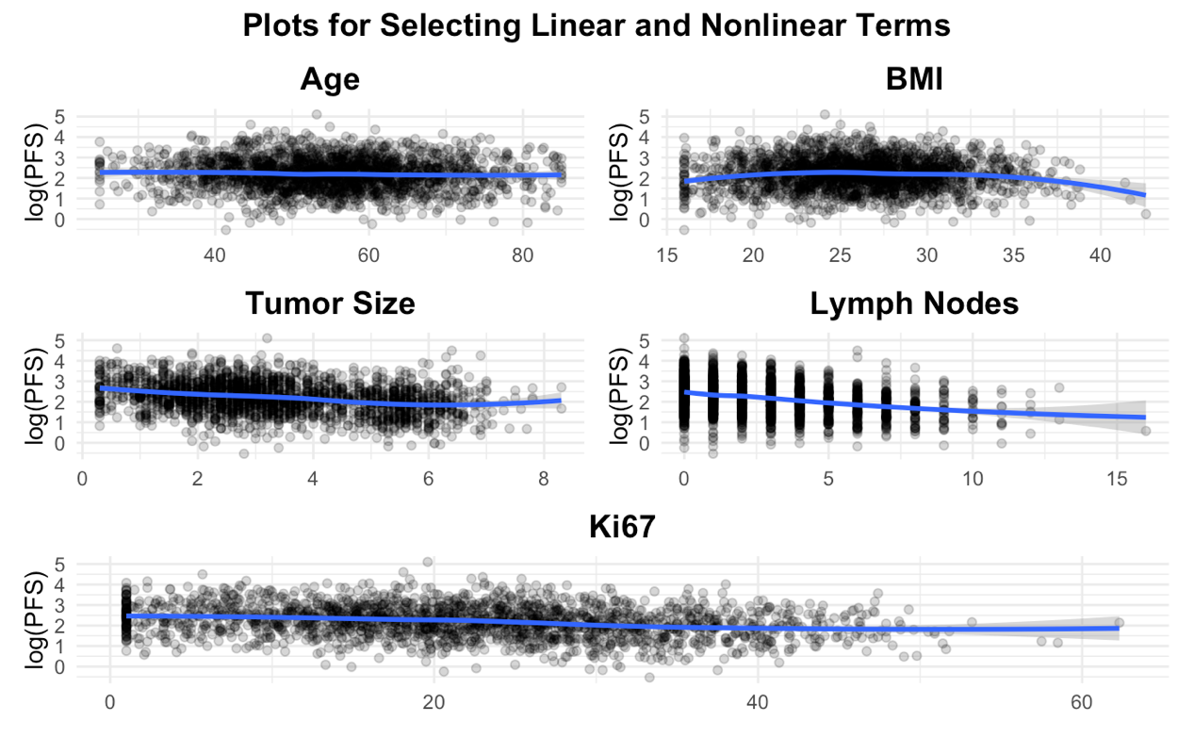
Figure 1. Plots for Selecting Linear and Nonlinear Terms in Data A

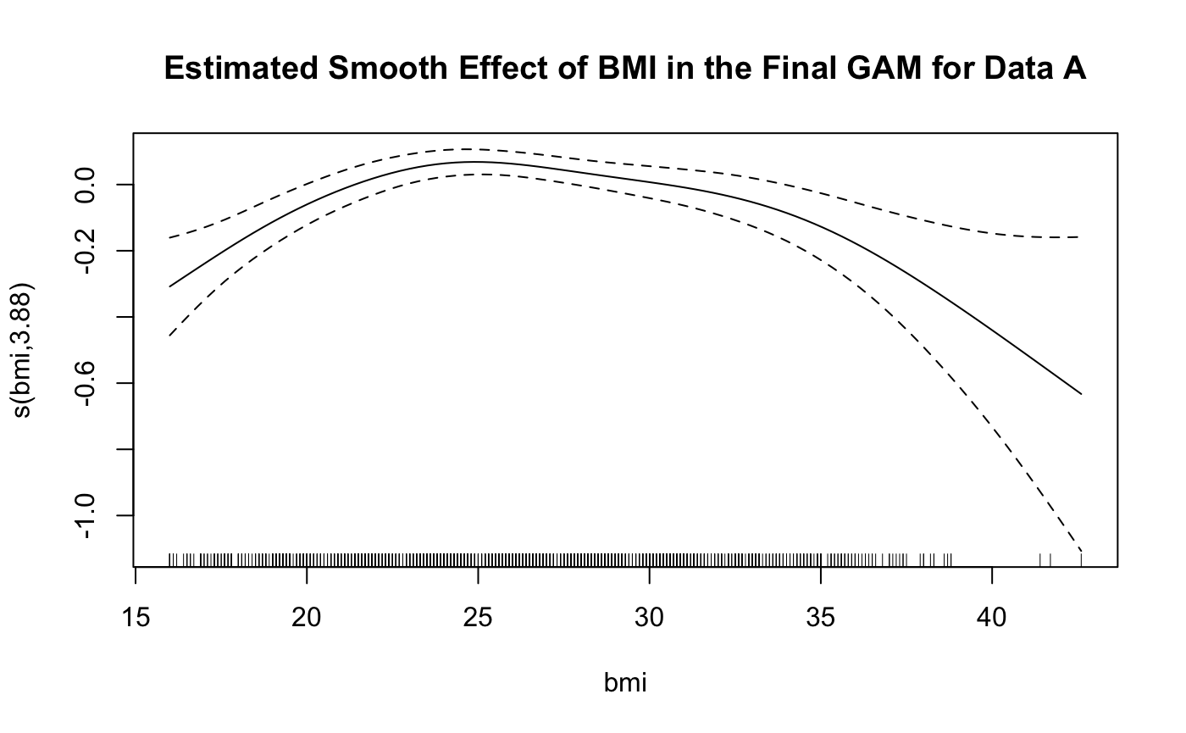
Figure 2. Estimated Smooth Effect of BMI in the Final GAM for Data A

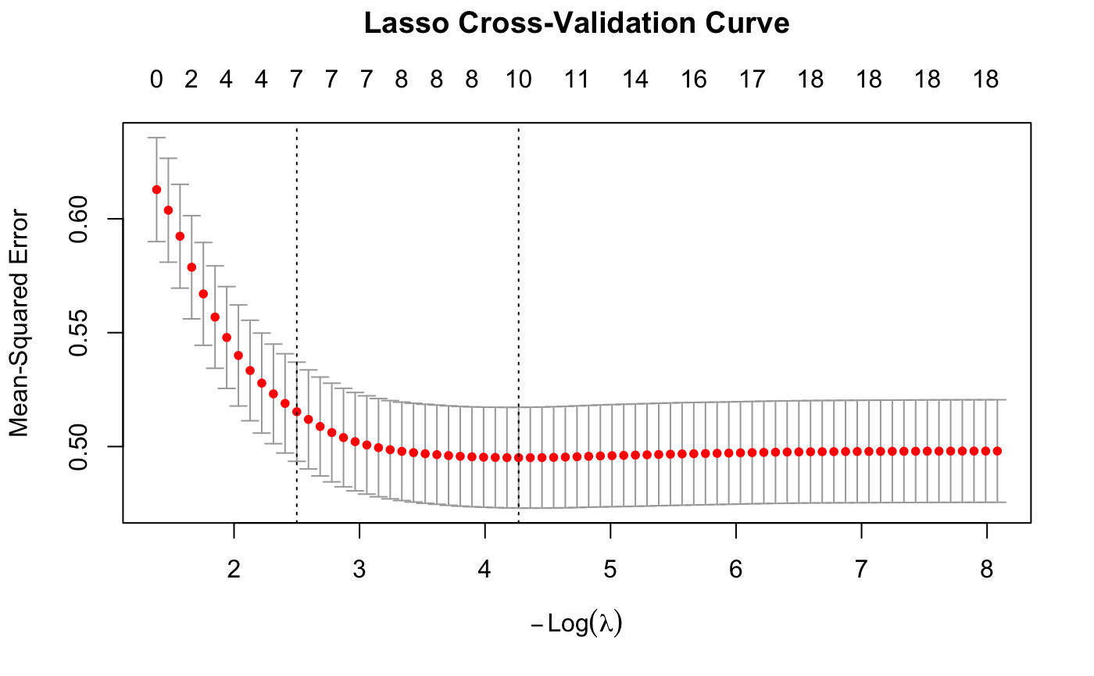
Figure 3. Lasso Cross-Validation Curve

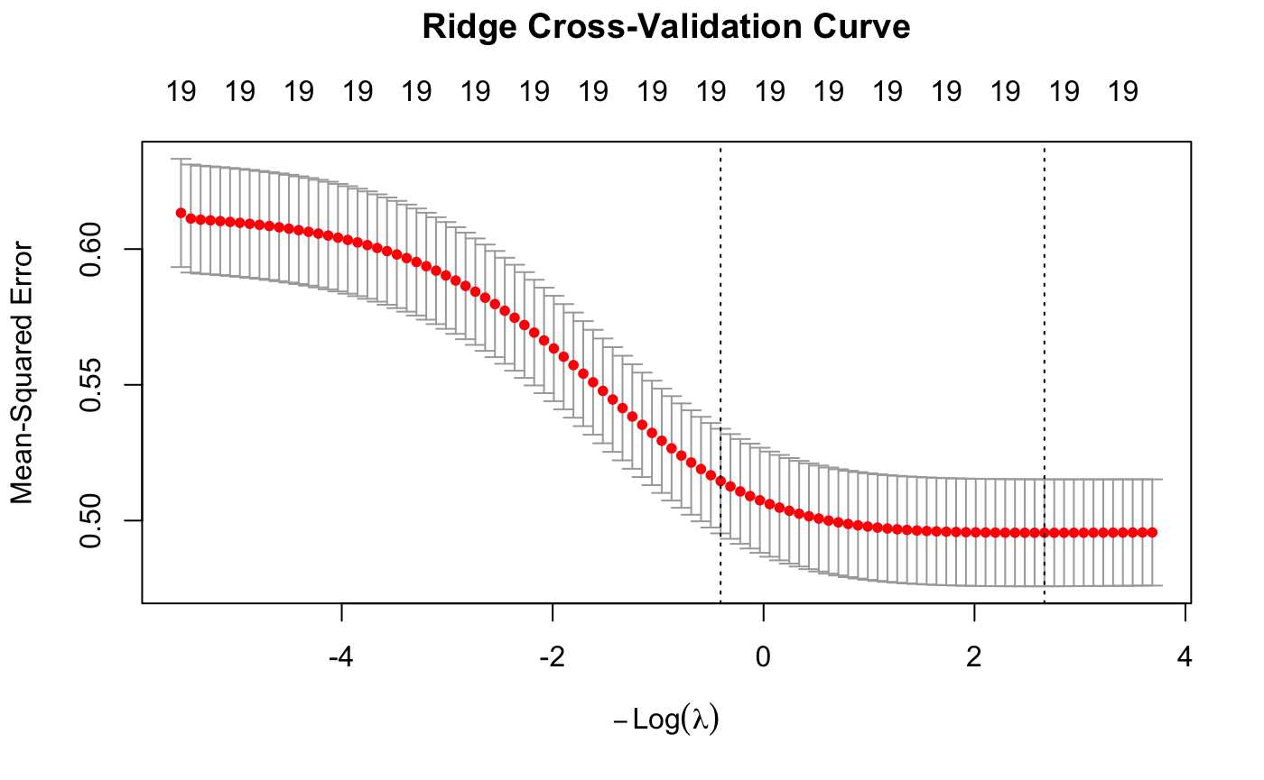
Figure 4. Ridge Cross-Validation Curve
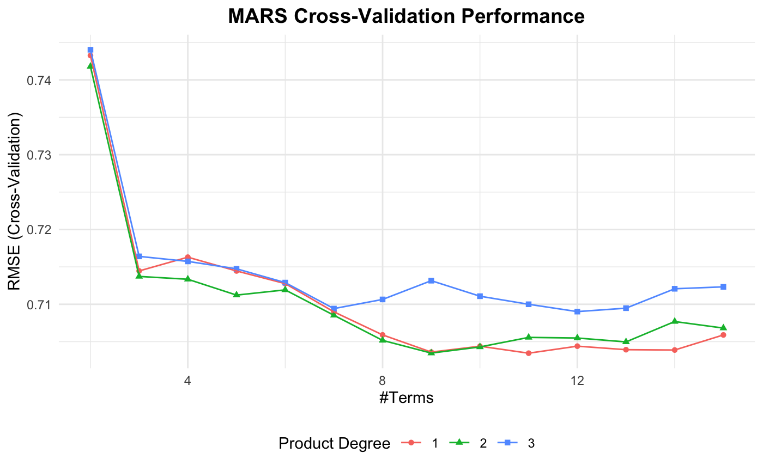
Figure 5. MARS Cross-Validation Performance

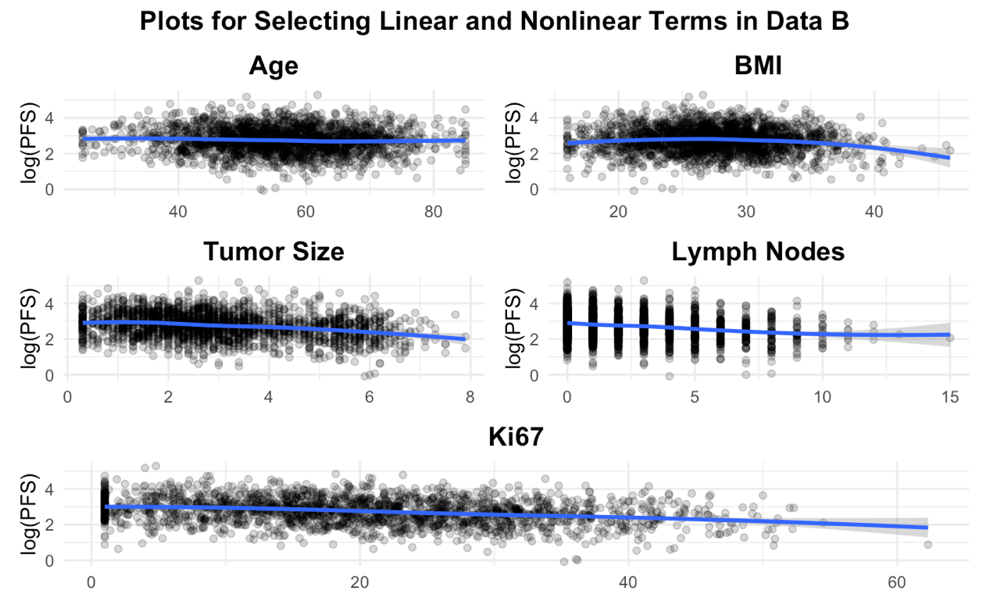
Figure 6. Plots for Selecting Linear and Nonlinear Terms in Data B

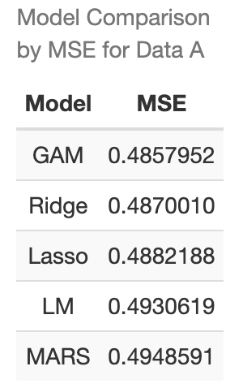
Table 1. Model Comparison by MSE for Data A
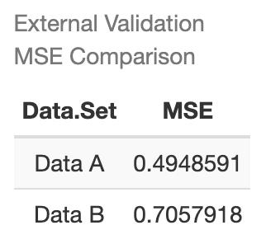
Table 2. External Validation MSE Comparison
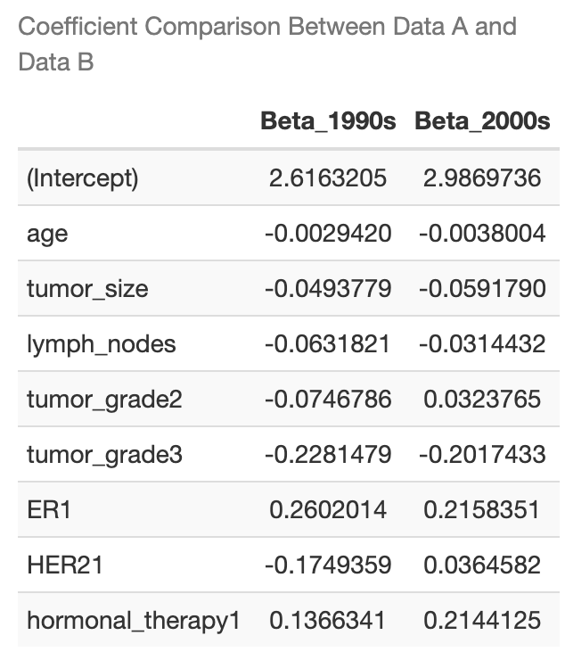
Table 3. Coefficient Comparison Between Data A and Data B
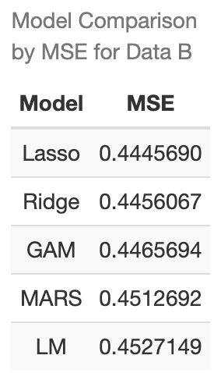
Table 4. Model Comparison by MSE for Data B
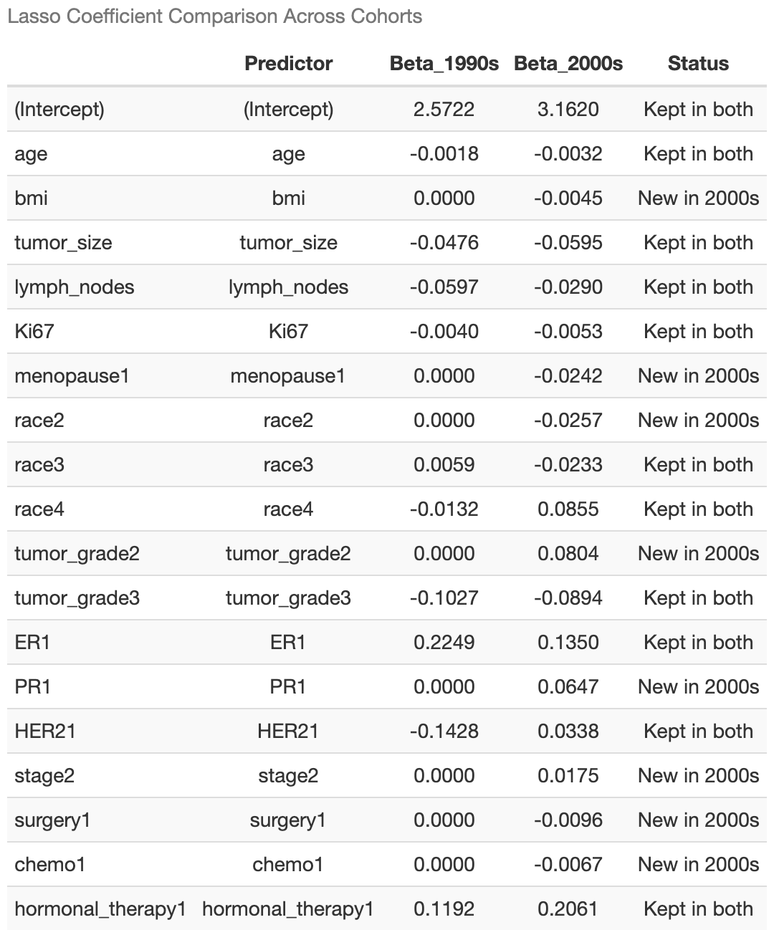
Table 5. Lasso Coefficient Comparison Across Cohorts

